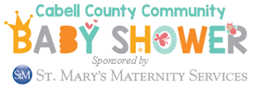

Exhibitor Registration

We would like to invite you to participate in the
Fifth Annual Cabell County Community Baby Shower!

This year, we’ll be hosting 100 moms-to-be and their guests for refreshments, games, speakers, and giveaways. The shower will begin with time for participants to browse tables hosted by you, our amazing community partners.
Save the Date!

When: Wednesday, April 24th, 11 am – 1 pm Where: St. Mary’s Conference Center
Vendor set-up 9:30 am – 10:30 am 2849 5th Avenue (Doors open to moms at 10:30) Huntington, WV 25702

To host a table at this event or provide materials for distribution, please complete and email or fax this form as soon as possible to:

April Knight
april@teamwv.org
office: 304-523-9587 ext. 302
cell: 304-412-6602
fax: 304-523-9595

Organization: __________________________________________________

Contact person: _______________________________________________

Phone: _____________________________________

Email: _____________________________________

Please briefly describe the resources or information provided at your table:

__________________________________________________________________________________________________
__________________________________________________________________________________________________

In lieu of a table registration fee, we invite exhibitors to donate a door prize or other items. If a table fee is more convenient for you, we are more than happy to accept that instead. We request door prizes be delivered by April 15th, if possible. Please feel free to contact me with any questions.

Item(s) to be donated: _____________________________________________________________

Approximate retail value: $ ________

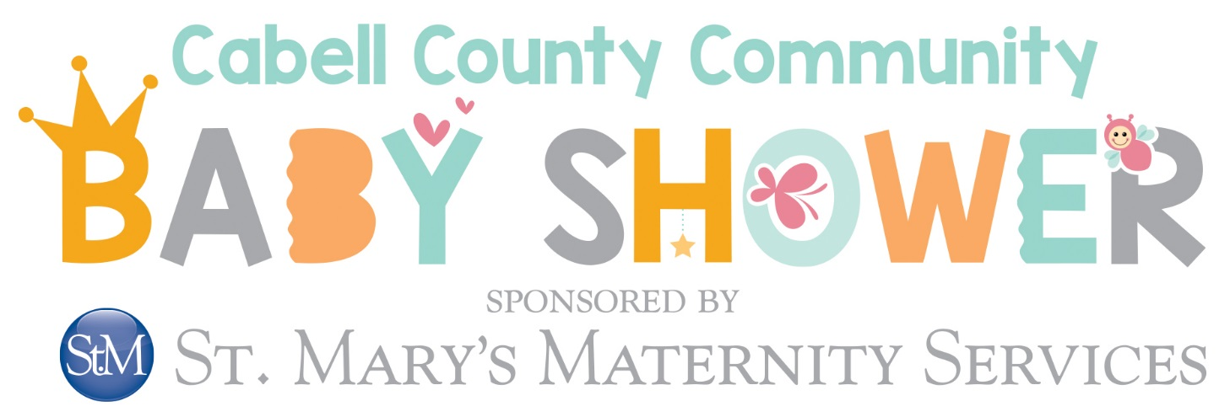

DOOR PRIZE WISH LIST

HERE ARE A FEW OF OUR MOST-REQUESTED BABY ITEMS.
WE WOULD LOVE TO PROVIDE AS MANY OF THESE AS POSSIBLE AT THIS YEAR’S SHOWER!

- Rocking Chair
- Travel System Stroller
- Baby Swing
- Car Seat
- Double Electric Breast Pump
- Baby Monitor
- Crib
- High Chair
- Baby Gate & Home Safety Supplies
- Bouncer or Activity Mat
- Exersaucer or Walker
- Baby Carrier
- Baby Bath, Faucet Cover, & Bath Thermometer
- Nursing Pillow, Cover, & Breastfeeding Supplies

